The Rule of Four
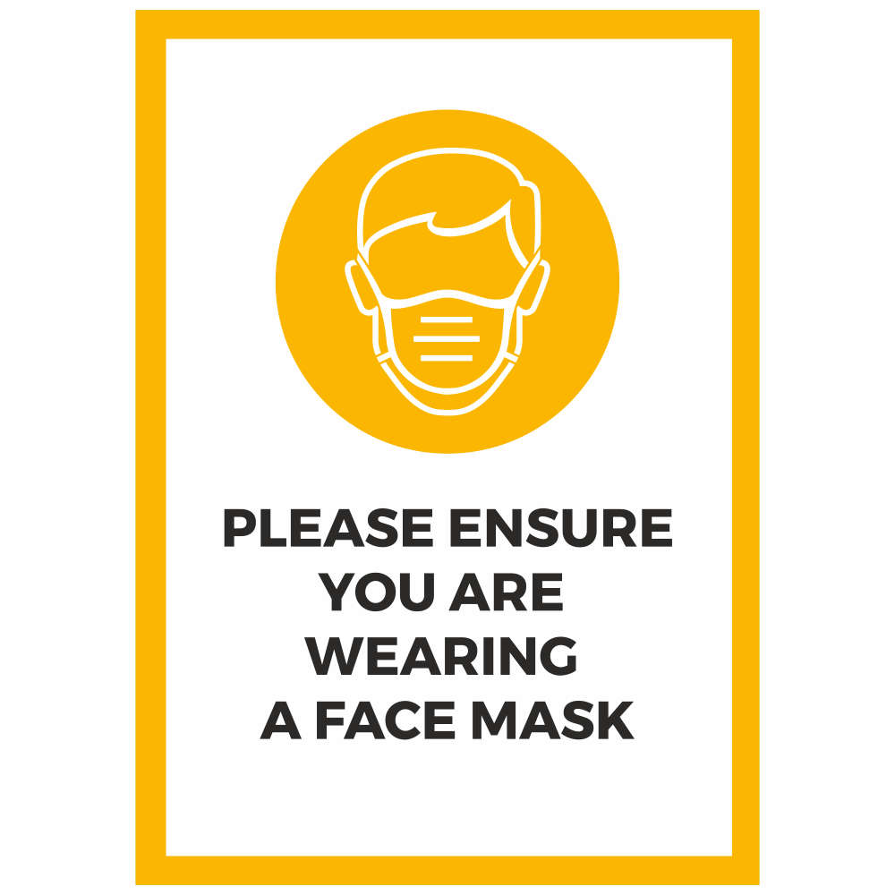
- Wear a Mask (11 Years and Over)
- Wash/Sanitise Hands Regularly
- Socially Distance
- Use NHS Track/Trace QR Code

